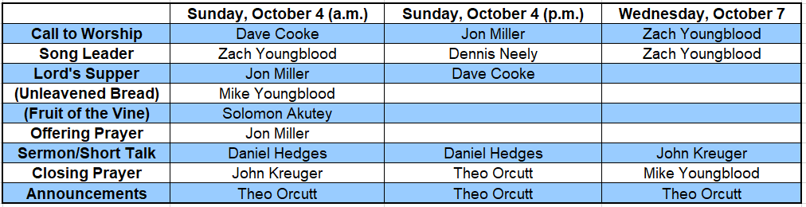

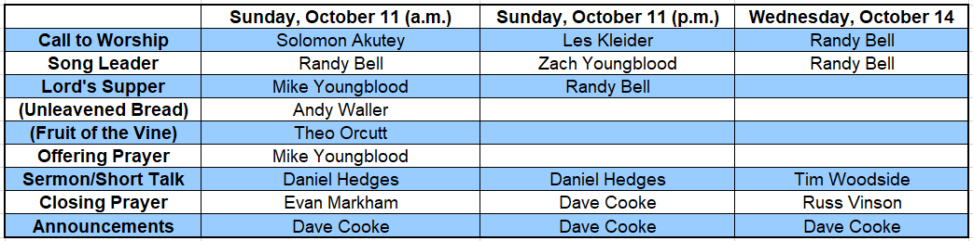

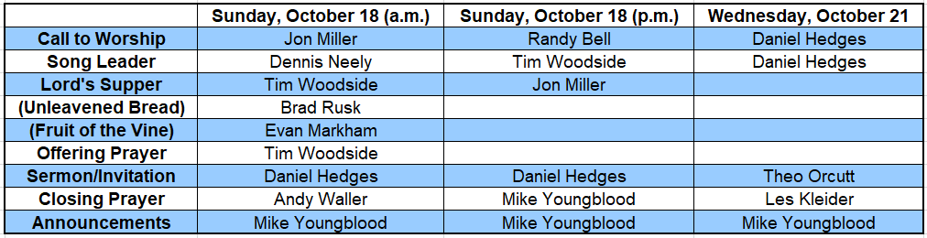

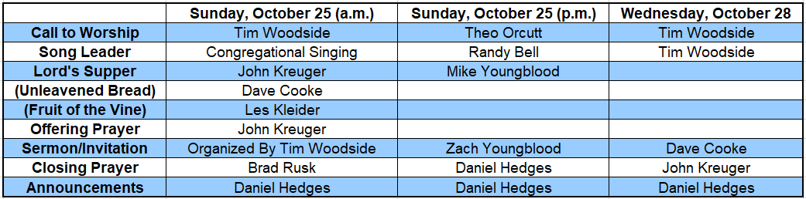

**Thank you for your willingness to serve.**